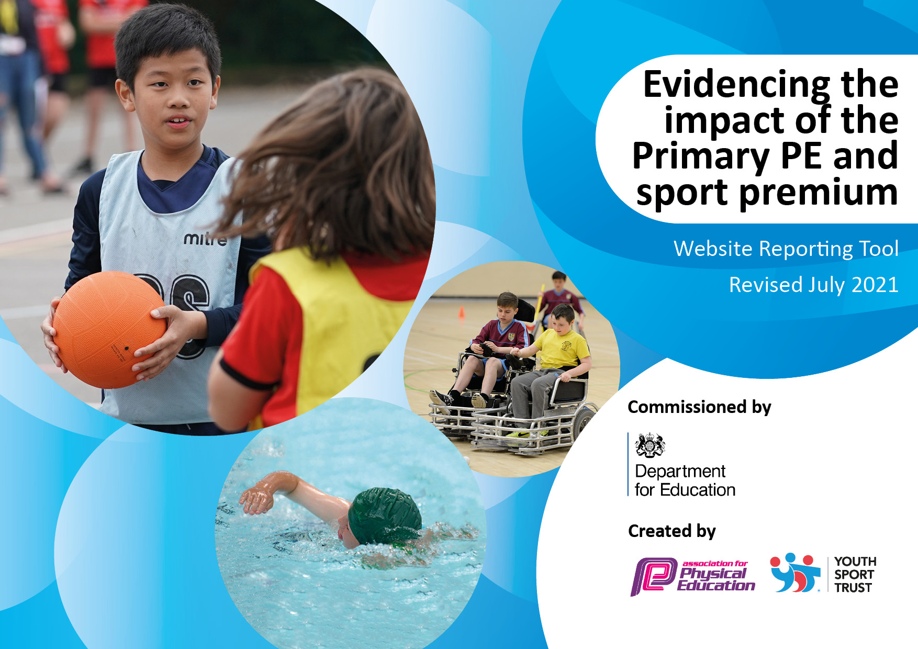

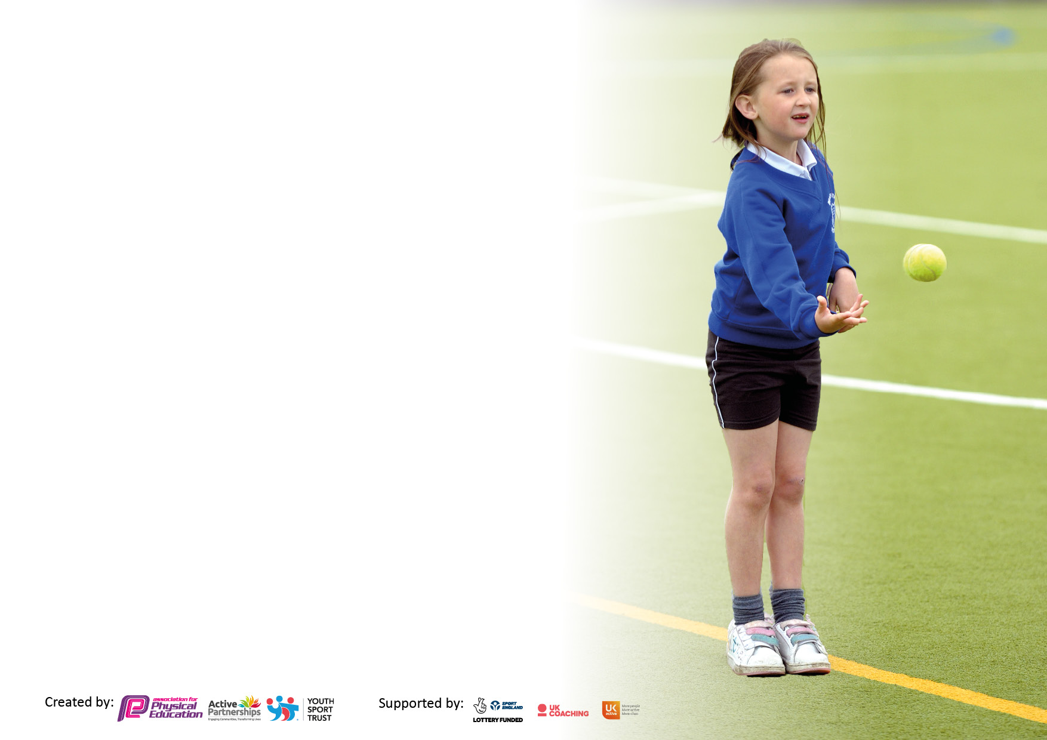

It is important that your grant is used effectively and based on school need. The Education Inspection Framework makes clear there will be a focus on ‘whether leaders and those responsible for governors all understand their respective roles and perform these in a way that enhances the effectiveness of the school’.

Under the Quality of Education Ofsted inspectors consider:
Intent - Curriculum design, coverage and appropriateness
Implementation - Curriculum delivery, Teaching (pedagogy) and Assessment
Impact - Attainment and progress

To assist schools with common transferable language this template has been developed to utilise the same three headings which should make your plans easily transferable between working documents.

Schools must use the funding to make additional and sustainable improvements to the quality of Physical Education, School Sport and Physical Activity (PESSPA) they offer. This means that you should use the Primary PE and sport premium to:

- Develop or add to the PESSPA activities that your school already offer
- Build capacity and capability within the school to ensure that improvements made now will benefit pupils joining the school in future years
- The Primary PE and sport premium should not be used to fund capital spend projects; the school’s budget should fund these.

Pleasevisitgov.ukfortherevisedDfEguidanceincludingthe5keyindicatorsacrosswhichschoolsshoulddemonstrate animprovement.Thisdocumentwillhelpyoutoreviewyourprovisionandtoreportyourspend.DfEencouragesschools to use this template as an effective way of meeting the reporting requirements of the Primary PE and sport premium.

We recommend you start by reflecting on the impact of current provision and reviewing the previous spend.

Schools are required to publish details of how they spend this funding, including any under-spend from 2019/2020, as well as on the impact it has on pupils’ PE and sport participation and attainment. All funding must be spent by 31st July 2022.

We recommend regularly updating the table and publishing it on your website throughout the year. This evidences your ongoing self-evaluation of how you are using the funding to secure maximum, sustainable impact. Final copy must be posted on your website by the end of the academic year and no later than the 31st July 2021. To see an example of how to complete the table please click HERE.

Details with regard to funding
Please complete the table below.

Total amount carried over from 2020/21 | £0
Total amount allocated for 2021/22 | £17,800
How much (if any) do you intend to carry over from this total fund into 2022/23? | £
Total amount allocated for 2022/23 | £6,362
Total amount of funding for 2021/22. To be spent and reported on by 31st July 2022. | £17,800
Swimming Data
Please report on your Swimming Data below.

Meeting national curriculum requirements for swimming and water safety.

N.B. Complete this section to your best ability. For example you might have practised safe self-rescue techniques on dry land which you can then transfer to the pool when school swimming restarts.
Due to exceptional circumstances priority should be given to ensuring that pupils can perform safe self rescue even if they do not fully meet the first two requirements of the NC programme of study
What percentage of your current Year 6 cohort swim competently, confidently and proficiently over a distance of at least 25 metres?  N.B. Even though your pupils may swim in another year please report on their attainment on leaving primary school at the end of the summer term 2020.  Please see note above | %
What percentage of your current Year 6 cohort use a range of strokes effectively [for example, front crawl, backstroke and breaststroke]?  Please see note above | %
What percentage of your current Year 6 cohort perform safe self-rescue in different water-based situations? | %
Schools can choose to use the Primary PE and sport premium to provide additional provision for swimming but this must be for activity over and above the national curriculum requirements. Have you used it in this way? | Yes/No

Action Plan and Budget Tracking
Capture your intended annual spend against the 5 key indicators. Clarify the success criteria and evidence of impact that you intend to measure to evaluate for pupils today and for the future.

Academic Year: 2020/21 | Total fund allocated: | Date Updated:
Key indicator 1: The engagement of all pupils in regular physical activity – Chief Medical Officers guidelines recommend that primary school pupils undertake at least 30 minutes of physical activity a day in school |  |  |  | Percentage of total allocation:
 |  |  |  | %
Intent | Implementation |  | Impact
Your school focus should be clear what you want the pupils to know and be able to do and about  what they need to learn and to  consolidate through practice: | Make sure your actions to achieve are linked to your intentions: | Funding allocated: | Evidence of impact: what do pupils now know and what can they now do? What has changed?: | Sustainability and suggested next steps:
To invest in Moki to ensure that fitness and activity levels are monitored accurately in the school. | - 2 weekly slots for each year group so they can be monitored for their activity levels for a sustained period of time. Classes with low activity levels will be given interventions delivered by coaches to increase their activity levels. Children with the highest level will receive a reward. | £1600  £270 | We will have accurate assessment of activity levels in school and during break-times. This will enable us to make ensure that all children are being physically active for at least 30 minutes a day.  For those children that aren’t, interventions will be put in place with either the Subject Lead or our coaching company. | To use Moki for the remainder of the year. If it is successful, then look towards getting another class set so we can have KS1 and KS2 both taking part together.
To ensure that all children are given equal opportunity to be physically active | Sports coaches will hold interventions for children with E.A.L, S.E.N.D. and PP children | £454 | All children will feel confident in being physically active and support staff will have CPD | Interventions to continue next academic year. Look at specialist coaches to come in to ensure all sessions are beneficial to the children.
To invest in EYFS to help aid fine and gross motor skills. | EYFS Lead and P.E. Lead will meet and order equipment that links with the EYFS curriculum | £945  £518 | Children in EYFS will improve their fine and gross motor skills which will ensure that they are more prepared for KS1. | To continue to work with the EYFS lead next year and develop their outdoor area.
Key indicator 2: The profile of PESSPA being raised across the school as a tool for whole school improvement |  |  |  | Percentage of total allocation:
 |  |  |  | %
Intent | Implementation |  | Impact
Your school focus should be clear what you want the pupils to know and be able to do and about  what they need to learn and to  consolidate through practice: | Make sure your actions to achieve are linked to your intentions: | Funding allocated: | Evidence of impact: what do pupils now know and what can they now do? What has changed?: | Sustainability and suggested next steps:
Sports leaders program to continue to be embedded to raise expectations in physical activity outside of curriculum time. | Subject lead to monitor the progress and efficiency of the current Year 6 leaders in school. Use coaching schemes Year 5 children to promote physical activity at lunchtimes for the next academic year through the use of medals during “Praise Assembly” | £100 | Pupils in Year 6 who have shown a willing attitude to learn and improve in P.E. have acted on their training given to them by the Subject Lead and the coach.  They have made decisions in how to increase fitness levels across the school and have raised money to ensure that we are able to fund any extra equipment needed.  They have also made an audit of the equipment and given feedback to the P.E. Lead who has then been able to order items needed to help improve P.E. lessons and breaktimes.
Raise the children’s understanding of having a healthy lifestyle outside of school. | Invest in Specialists Coaches to come in for Special Days  Bhangra £345  Golf £600  Wheelchair Basketball £420  Bikeability _______ | £1,365 | Children will have a better understanding of the variety of sports accessible to everyone.

Key indicator 3: Increased confidence, knowledge and skills of all staff in teaching PE and sport |  |  |  | Percentage of total allocation:
 |  |  |  | %
Intent | Implementation |  | Impact
Your school focus should be clear | Make sure your actions to | Funding | Evidence of impact: what do | Sustainability and suggested
what you want the pupils to know | achieve are linked to your | allocated: | pupils now know and what | next steps:
and be able to do and about | intentions: |  | can they now do? What has
what they need to learn and to |  |  | changed?:
consolidate through practice:
AfPE Membership to be renewed. | To ensure that we are following the government guidance and being offered CPD or extra support when needed. | £75 | • Coordinator upskilled and able to support development of other staff.  • Membership of professional organisations ensures school has latest knowledge, guidance and resources | Continue to use AfPE to support our teaching and learning of P.E.
ECT’s will deliver high-quality P.E. lessons using the curriculum set out for them. | ECT’s will be given a questionnaire based on what sports they feel confident in teaching. CPD will be arranged through the subject lead or sports coaches. | £454  _______ | Members of staff will feel confident in their teaching of P.E. and the children will then receive a high-quality P.E. lesson where all children are given the opportunity to be physically active.
Key indicator 4: Broader experience of a range of sports and activities offered to all pupils |  |  |  | Percentage of total allocation:
Intent | Implementation |  | Impact
Your school focus should be clear | Make sure your actions to | Funding | Evidence of impact: what do | Sustainability and suggested
what you want the pupils to know | achieve are linked to your | allocated: | pupils now know and what | next steps:
and be able to do and about | intentions: |  | can they now do? What has
what they need to learn and to |  |  | changed?:
consolidate through practice:
To improve and add to the equipment being used to teach P.E. and during breaktimes. | Investing into the PE equipment to ensure that there is enough for the children to have at break-time and during PE sessions. | £3,028  Storage unit- £747  Table Tennis- £465 | Pupils have an active and enjoyable lunchtime.  Pupils learn and participate in new sports, developing new skills, resulting in an increase of pupils’ health and fitness  Positive impact on behaviour and social skills through being engaged in sport  Pupils have active lunchtimes – even fewer behaviour incidents  Pupils report increased enjoyment of being active in a variety of sporting domains
A professional sports coach to lead on After-School Clubs for KS1 and KS2 children. | Source a highly skilled sports coach. Monitor the effectiveness of the of the After-School clubs through parent surveys. | £2660 | Children are given the opportunity to try new sports and find sport that they are passionate about. This will then lead to the children joining clubs based around the sports and enable them to be more physically active at home.
Provide additional swimming for children in Year 4 and a larger group of Year 6 pupils not meeting end of KS expectations | Arrange with Sandwell Leisure Trust when they have availability for us to have additional sessions over the spring term  Arrange consent forms and risk Assessments  Ask SLT to run baseline tests so intervention can be measured | £300 | An intervention at the end of the academic year is required to reduce the number of children having SEN in swimming heading into KS3 in September 2020 for a larger number of pupils than in previous years and so this may impact the time given to Year 4 pupils this year. | Ensure that Year 6 have a higher percentage of children who can swim up to 25m. (60%)  We have identified children from Year 5 who will need the extra support and funding from next year will be used to ensure that we are able to hit the 60+% that we are aiming for in the next academic year.

Key indicator 5: Increased participation in competitive sport |  |  |  | Percentage of total allocation:
 |  |  |  | %
Intent | Implementation |  | Impact
Your school focus should be clear | Make sure your actions to | Funding | Evidence of impact: what do | Sustainability and suggested
what you want the pupils to know | achieve are linked to your | allocated: | pupils now know and what | next steps:
and be able to do and about | intentions: |  | can they now do? What has
what they need to learn and to |  |  | changed?:
consolidate through practice:
To increase our participation in inter and intra competitions. Through the use of MAC Sports Days, SCOS Commonwealth games and varied sport specific competitions. | Speak with our Principle to ensure that we are able to take part in as many different competitions as possible. | £225 | Children in all year groups have taken part in an out of school competition and been able to compete with other schools to a good standard. | Improve on the variety of sports that we are competing in.
Make sure that all children are given the opportunity to take part in competitions in school | Children with S.E.N.D and PP children will take part in competitions based around their additional needs. | £454 | Children will be given the opportunity to compete with each other in class during interventions/coaching sessions.

Signed off by
Head Teacher:
Date:
Subject Leader:
Date:
Governor:
Date:

